Lucinda L. Peterson, CPA, CFP

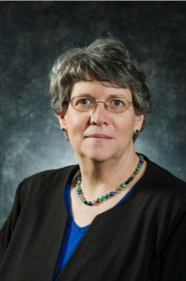
Cindy is a Senior Advisor and the CFO of Lau Associates LLC, a financial planning and wealth management firm. Her focus at Lau is on tax and estate planning. Prior to joining Lau she had a solo accounting practice, L Peterson PA. Her professional career began as an accountant with Daney, Truitt and Company. She remained with the company through several mergers and ultimately became a Partner and Tax Director of Truitt, Sarnecki & Associates. She left Truitt, Sarnecki & Associates to start her solo practice in 1998. She received a Bachelor of Science degree in accounting from the University of Delaware in 1978 and obtained her CPA designation in 1984. She received her CFP® license in 2005.

She is a member of the American Institute of Certified Public Accountants and the Financial Planning Association.

She has been a member of the board of directors of Tri-State Bird Rescue for 15 years and has held the positions of Treasurer, President and is currently the 2nd Vice-President and Chair of the Audit Committee.

